**TRƯỜNG ĐẠI HỌC TÔN ĐỨC THẮNG**

**KHOA ĐIỆN – ĐIỆN TỬ**

**NGÀNH ĐIỆN TỬ – VIỄN THÔNG**



**ĐIỆN TỬ CÔNG SUẤT**

ĐỀ TÀI:

***Computing and modelling AC-DC converter using uncontrolled rectifer and DC-DC chopper***

**Giảng viên phụ trách:** *NGUYỄN HOÀNG NAM*

**Người thực hiện:** *NGUYỄN ĐỨC TRÍ*

**MSSV:** *41900297*

**THÀNH PHỐ HỒ CHÍ MINH, NĂM 2021**

**LỜI CẢM ƠN**

First of all, I would like to express my sincere thanks to Ton Duc Thang University for introducing Power Electronics into the curriculum.

In particular, I would like to express my deep gratitude to the subject lecturer - Mr. Nguyen Hoang Nam. After researching topic 6, we practiced by making a factual report on this topic. After completing the report, we have gained useful experiences and knowledge drawn from the report. This is the first time we do a report, we are inexperienced, so there may be some errors in the report, please guide us so that we can have better reports for other subjects in the future.

We would like to thank the teacher for wholeheartedly guiding us to study this subject well, thank you for your enthusiastic guidance so that we can have the most complete report with our ability and knowledge.

We wish you a lot of health, happiness, and success in your teaching career

Best regards.

**LỜI CAM ĐOAN**

I hereby declare that the Final Report of the Power Electronics course _N01_group 6 has been researched and implemented by me and my friends. We have checked the data according to current regulations.

Results The final report is truthful and not copied from any other group's report. The materials used in the Final Report have clear origins.

**nhận xét**

**của giáo viên hướng dẫn**

…............................................................................................................................................…............................................................................................................................................…............................................................................................................................................…............................................................................................................................................…............................................................................................................................................…............................................................................................................................................…............................................................................................................................................…............................................................................................................................................…............................................................................................................................................…............................................................................................................................................…............................................................................................................................................…............................................................................................................................................…............................................................................................................................................…............................................................................................................................................…............................................................................................................................................…............................................................................................................................................…...........................................................................................................................

TP. HCM, ngày … tháng … năm 2021

GIẢNG VIÊN HƯỚNG DẪN

(Ký và ghi rõ họ tên)

**MỤC LỤC**

*1)* *Buck* 8

1.1. CALCULATION OF DATA 8

1.1.1. Half-Wave uncontrolled Rectifier 8

1.1.2. Buck converter (Step-down) 9

SOLUTION: 10

1.2. MATLAB SIMULATION 12

1.2.1. Half-Wave uncontrolled Rectifier 15

1.2.2. Buck Converter 17

1.2.3. Scope 19

1.3. VERIFY THE RESULTS 22

*2)* *Boost* 23

2.1. CALCULATION OF DATA 23

2.1.1 Full-Wave uncontrolled (centre-tap) 23

2.1.2 Boost Converter (Step-Up) 24

SOLUTION: 25

2.2. MATLAB SIMULATION 27

2.2.1. Full-Wave uncontrolled (Centre-tap) 30

2.2.2. Boost Converter 32

2.2.3. Scope 34

2.3. VERIFY THE RESULTS 38

**LINK to**

**the presentation**

https://drive.google.com/file/d/1UPks0YqDWQem4n-oFHQxPj297xBtF0ug/view?usp=sharing

**Threads**

|  |  |  |  |  |
| --- | --- | --- | --- | --- |
| Project  ID | Rectifier | Input Voltage | Chopper | Output Voltage |
| 6 | Half-Wave uncontrolled | 380V | Buck |  |
| Full-Wave uncontrolled (centre-tap) | 220V | Boost |  |

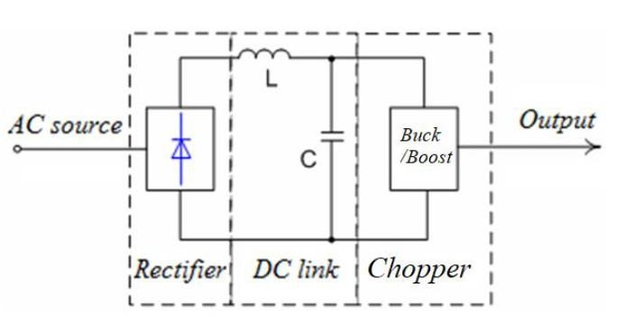

Buck: Output Voltage = (Out-Rectifier) / ((1+(số cuối MSSV/10)) x 1.05)

Ví dụ: Nếu MSSV 41xxxxx7 thì bộ Buck có

Output voltage / Input Voltage =1 / ((1+7/10) x 1.05) = 0.560

Boost: Output Voltage = (Out-Rectifier) x ((1+(số cuối MSSV/10)) x 1.05)

Ví dụ: Nếu MSSV 41xxxxx7 thì bộ Boost có

Output voltage / Input Voltage = (1+7/10) x 1.05 = 1.785

*General requirements*

* For topics 1-5: theoretical calculation of the excitation angles α of rectifiers (and hysteresis angles for the case of Quasi-square-wave inverters). Explain how to calculate values; the effective value of harmonics (high harmonics) order 3, 5; total distortion due to high order harmonics (THD).
* For topics number 6-10: theoretical calculation of the coefficients D of the chopper. Explain how the values are calculated; Calculate the minimum inductance value of the coil to ΔiL ≤ 0.5 A (with R = 100 Ω); Calculate the minimum capacitance value of the capacitor to Δvo ≤ 1 V.
* Simulate circuits in MATLAB.
* Verify simulation results and theoretical calculation results.

**Calculation part**

|  |  |  |  |
| --- | --- | --- | --- |
| Rectifier | Input Voltage | Chopper | Output Voltage |
| Half-Wave uncontrolled | 380V | Buck | *(Tính toán)* |

# *Buck*

## CALCULATION OF DATA

### Half-Wave uncontrolled Rectifier

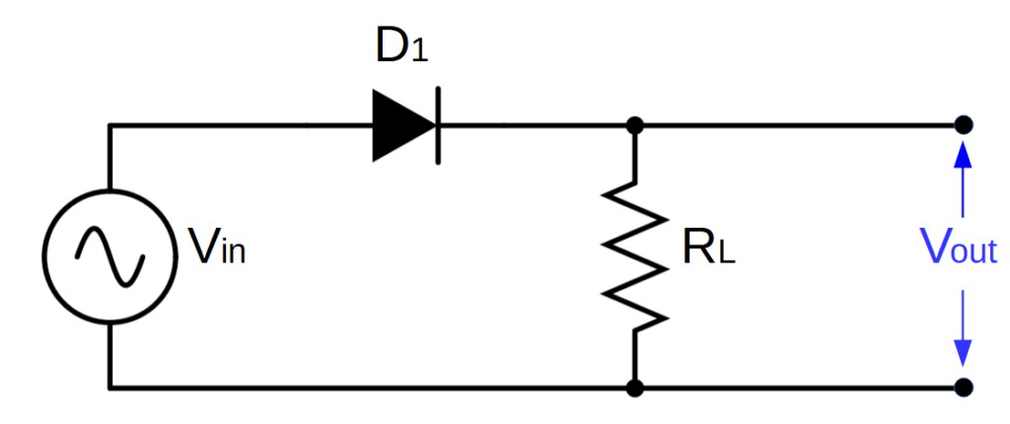

We have

* Input Voltage = 𝑉𝑖𝑛 = 𝑉𝑚 = 380𝑉
* 𝑓 = 50𝐻𝑧

We calculate:

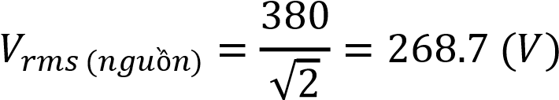

Select components of DC Link:

𝐿𝑙𝑖𝑛𝑘 = 1𝜇𝐻

𝐶𝑙𝑖𝑛𝑘 = 50𝑚F

Measured output of Rectifier & DC link is V𝑜𝑢𝑡−𝑟𝑒𝑐𝑡𝑖𝑓𝑖𝑒𝑟 = 380𝑉

### Buck converter (Step-down)

We have:

* 𝑅 = 100Ω
* ∆𝑖𝐿 ≤ 0.5𝐴 ⇒ 𝐶ℎoose ∆𝑖𝐿 = 0.5𝐴
* ∆𝑣𝑜 ≤ 1𝑉 ⇒ 𝐶ℎoose ∆𝑣𝑜 = 1𝑉
* Frequency 𝑓 = 40𝑘𝐻𝑧

### SOLUTION:



We choose L to be 30 times larger than 𝐿𝑚𝑖𝑛 ⇒ 𝐿 = 30× 𝐿𝑚𝑖𝑛 =

(𝐻)

2.1989 (A)

2.057 (A)

Winding ripple:

∆𝑖𝐿 = 𝐼𝐿𝑚𝑎𝑥 − 𝐼𝐿𝑚𝑖𝑛 = 2.1989 – 2.057= 0.1419 𝐴 < 0.5 A

Output oscillation coefficient:

Parameters of Key S and Diode:

## MATLAB SIMULATION

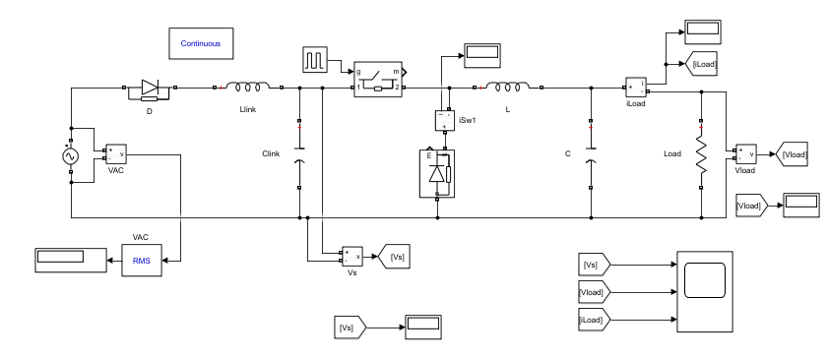

Components are obtained in the library (Simulink Library Browser)

* 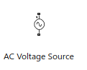AC Voltage Source
* 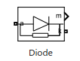Diode

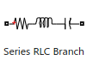

* Series RLC Branch (Capacitor; Resistor; Inductor)

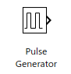

* Pulse Generator

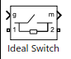

* Ideal Switch
* 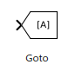Go to

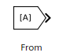

* From

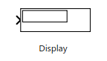

* Display

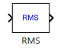

* RMS

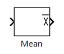

* Mean

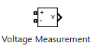

* Voltage Measurement

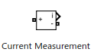

* Current Measurement



* Powergui
* 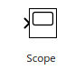Scope

### Half-Wave uncontrolled Rectifier

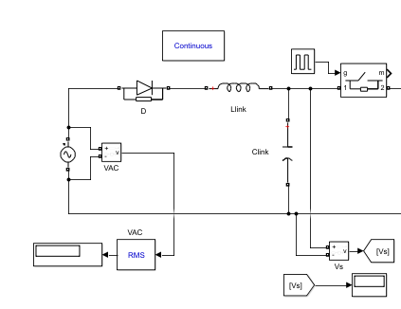

|  |  |
| --- | --- |
| INSTALLATION SPECIFICATIONS | MEASUREMENTS |
| * VAC=380 (V)      * Diode | * Vrms (nguồn) = 268.7 (V) * Vo = 380 (V) |

### Buck Converter

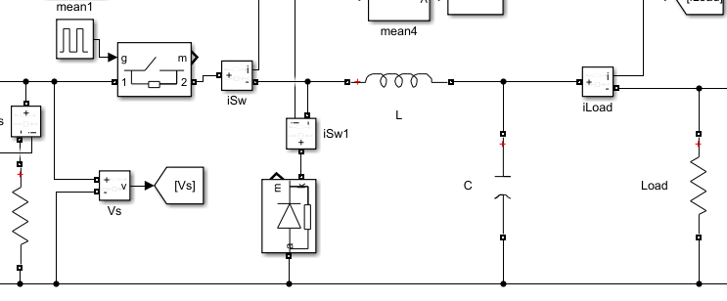

|  |  |
| --- | --- |
| CÁC THÔNG SỐ CÀI ĐẶT | CÁC THÔNG SỐ ĐO ĐƯỢC |
| * f = 40kHz ; D = 0.56      * L =      * C | * Vload = Vo = 212.5 (V) * Iload = 2.125 (A)      * Iswitch = 0.0038 A; * ID = 2.049 A |

### Scope

*Vs*

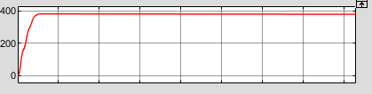

*Vload*

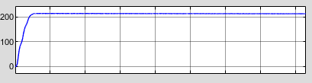

*Iload*

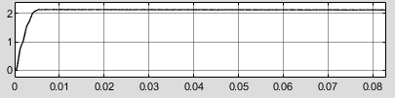

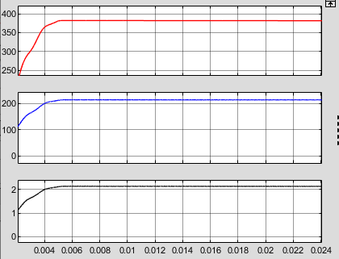

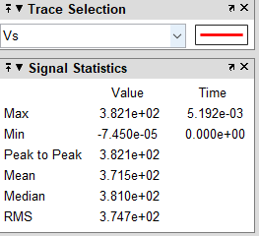

SPECIFICATION OF VS

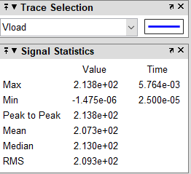

SPECIFICATION OF Vload

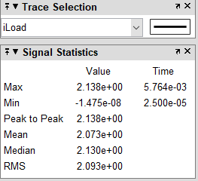

SPECIFICATION OF Iload

## VERIFY THE RESULTS

|  |  |  |
| --- | --- | --- |
|  | CALCULATE | SIMULATIONS |
| Vrms (source) | 268.7 V | 268.7 V |
| Vs = Vout-rectifier | 380 V | 380 V |
| Io | 2.1 A | 2.125 A |
| Vo=Vload | 212.8 V | 212.5 V |
| Iswitch; Id | 1.19168 A;  A | 0.0038 A;  2.049 A |

# *Boost*

|  |  |  |  |
| --- | --- | --- | --- |
| Rectifier | Input Voltage | Chopper | Output Voltage |
| Full-Wave uncontrolled  (centre-tap) | 220V | Boost | *(Tính toán)* |

## CALCULATION OF DATA

### 2.1.1 Full-Wave uncontrolled (centre-tap)

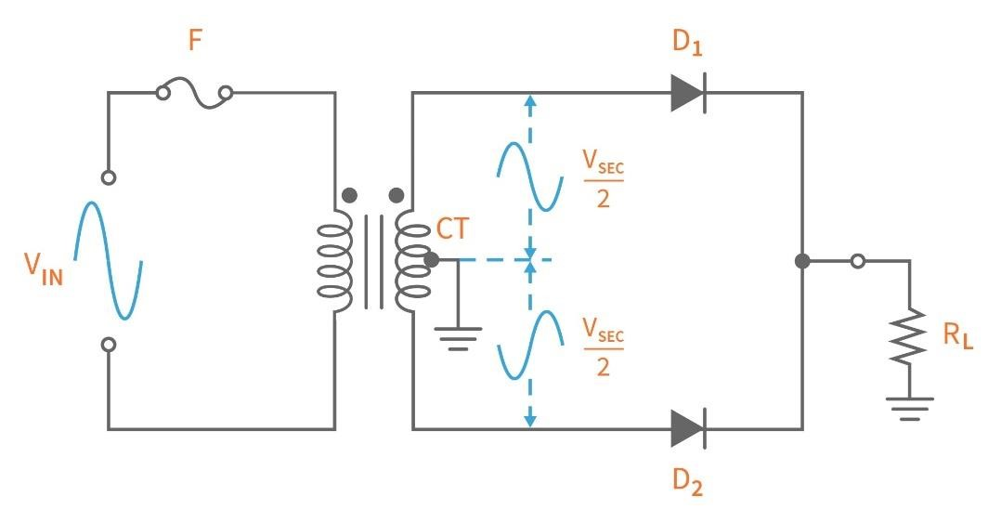

We have the following data:

* Input Voltage = 𝑉𝑖𝑛 = 𝑉𝑚 = 220 𝑉
* 𝑓 = 50𝐻𝑧

We can measure:



DC Link:



### 2.1.2 Boost Converter (Step-Up)

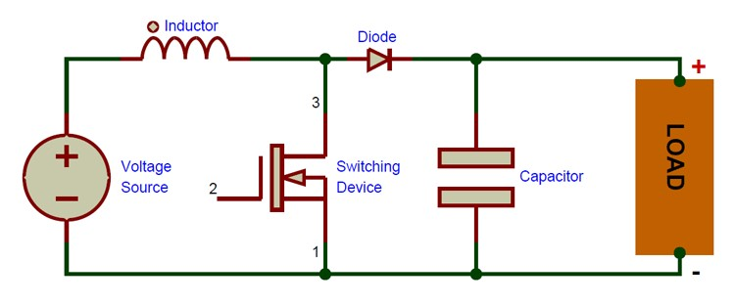

We have:

* 𝑅 = 100Ω
* ∆𝑖𝐿 ≤ 0.5𝐴 ⇒ 𝐶ℎoose ∆𝑖𝐿 = 0.5𝐴
* ∆𝑣𝑜 ≤ 1𝑉 ⇒ 𝐶ℎoose ∆𝑣𝑜 = 1𝑉
* Frequency 𝑓 = 40𝑘𝐻𝑧

### SOLUTION:

0.439

We choose L to be 30 times larger than 𝐿𝑚𝑖𝑛:

⇒ 𝐿 = 30 × 𝐿𝑚𝑖𝑛 = (𝐻)

7.223 (A)

6.757 (A)

Winding ripple:

∆𝑖𝐿 = 𝐼𝐿𝑚𝑎𝑥 − 𝐼𝐿𝑚𝑖𝑛 = 7.223 – 6.757= 0.466 𝐴 < 0.5 𝐴

Output Oscillator:

Parameters of Key S and Diode:

## MATLAB SIMULATION

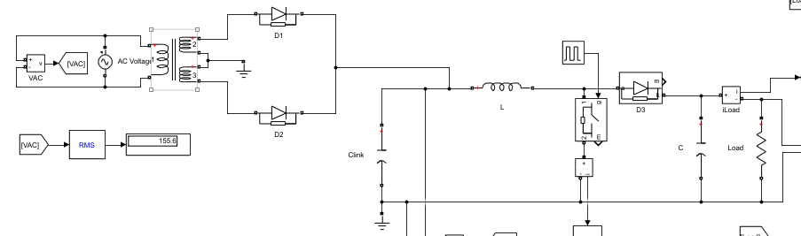

Components are obtained in the library (Simulink Library Browser)

* AC Voltage Source
* Diode



* Series RLC Branch (Capacitor; Resistor; Inductor)



* Pulse Generator



* Ideal Switch
* Go to



* From



* Display



* RMS



* Mean



* Voltage Measurement



* Current Measurement



* Powergui
* Scope

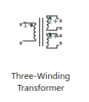

* Transformer

### Full-Wave uncontrolled (Centre-tap)

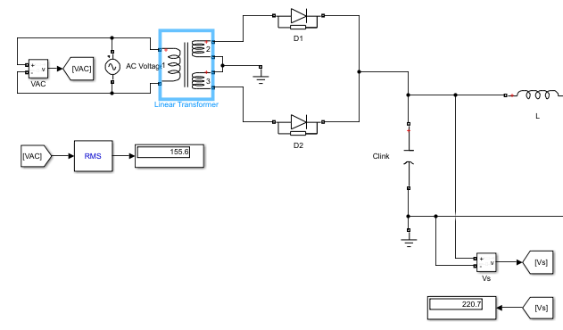

|  |  |
| --- | --- |
| INSTALLATION SPECIFICATIONS | MEASUREMENTS |
| * VAC = 220 V; f = 50 Hz            * Diode (D1;D2) | * Vrms (nguồn) = 155.6 V      * Vs = Vout−rectifier = 220.5 V |

### Boost Converter

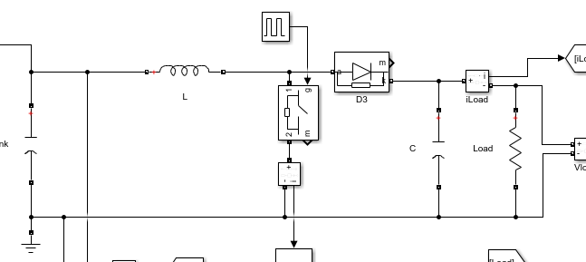

|  |  |
| --- | --- |
| INSTALLATION SPECIFICATIONS | MEASUREMENTS |
| * f = 40kHz ; D = 0.439      * L =      * C | * Vload = Vo = 397.4 V * Iswitch = 31.14 A * ID = Iload = 39.74 A |

### Scope

*VAC*

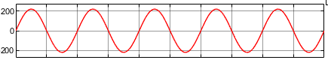

*Iload*

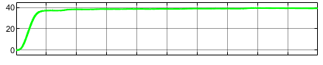

*VS*

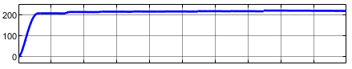

*Vload*

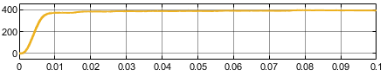

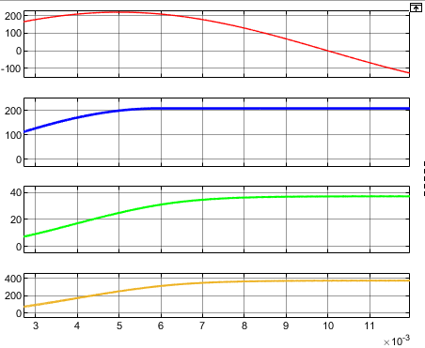

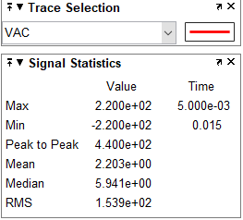

VAC SPECIFICATION

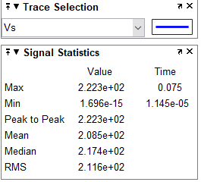

VS SPECIFICATION

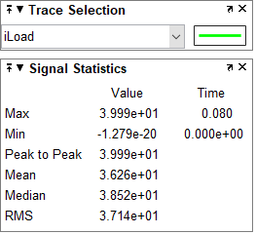

Iload SPECIFICATION

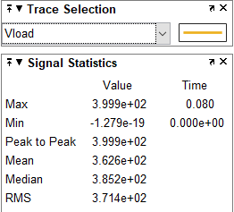

Vload SPECIFICATION

## VERIFY THE RESULTS

|  |  |  |
| --- | --- | --- |
|  | CALCULATE | SIMULATIONS |
| Vrms (Source) | 155.56 V | 155.6 V |
| Vs = Vout-rectifier | 220 V | 220.5 V |
| Iload | 39.7 A | 39.74 A |
| Vo=Vload | 392.7 V | 397.4 V |
| Iswitch; Id | A;  A | 31.14 A;  39.74 A |

**reference material**

[1]. Daniel W. Hart, [2011], Power electronics, 1e, McGraw-Hill, New York.

[2]. Muhammad H. Rashid, [2011], Power electronics handbook: devices, circuits, and applications handbook, 3e, Elsevier, Amsterdam.

[3]. Nguyễn Văn Nhờ, [2009], Điện tử công suất, Tái bản lần 3, NXB Đại học Quốc gia TPHCM, TPHCM.

[4] Youtube Video: How to Calculate and Design Boost Converter using MATLAB Simulink, Link: https://www.youtube.com/watch?v=PH8non3VAPc&t=433s

[5] Youtube Video: How to Calculate and Design Buck Converter using MATLAB Simulink, Link: https://www.youtube.com/watch?v=ZWs2HJZTWAA&t=54s

[6] Youtube Video: How to make Full Wave Bridge Rectifier circuit on MATLAB, Link: https://www.youtube.com/watch?v=3mrePJq2L1o

[7] Youtube Video: Lý thuyết-tính toán-mô phỏng bộ biến đổi DC DC, Link: https://www.youtube.com/watch?v=ffL57xoO13U&t=458s